Ideation Phase

Brainstorm & Idea Prioritization Template

Date | 11 February 2026
Team ID | LTVIP2026TMIDS88533
Project Name | Explore with AI: Custom Itineraries for Your Next Journey
Maximum Marks | 4 Marks

Step-1: Team Gathering, Collaboration and Select the Problem Statement

In the initial phase of the Explore with AI project, the team comes together to align on goals, roles, and expectations. The focus is on understanding the challenges of travellers and travel agencies face in planning personalized itineraries.
Key activities:

- Build a collaborative environment for sharing ideas and insights.
- Conducted brainstorming sessions to explore pain points in travel planning, such as information overload, difficulty in personalizing itineraries, and time-consuming research.

Identified a relevant, meaningful, and user-centered problem statement.
- For example:
“Travellers and agencies need an easy way to generate personalized, detailed travel itineraries without spending hours on research and planning.”
Outcome: A clear problem statement that guides the design and development of Explore with AI, ensuring the team is aligned and committed to solving a problem that truly matters to users.
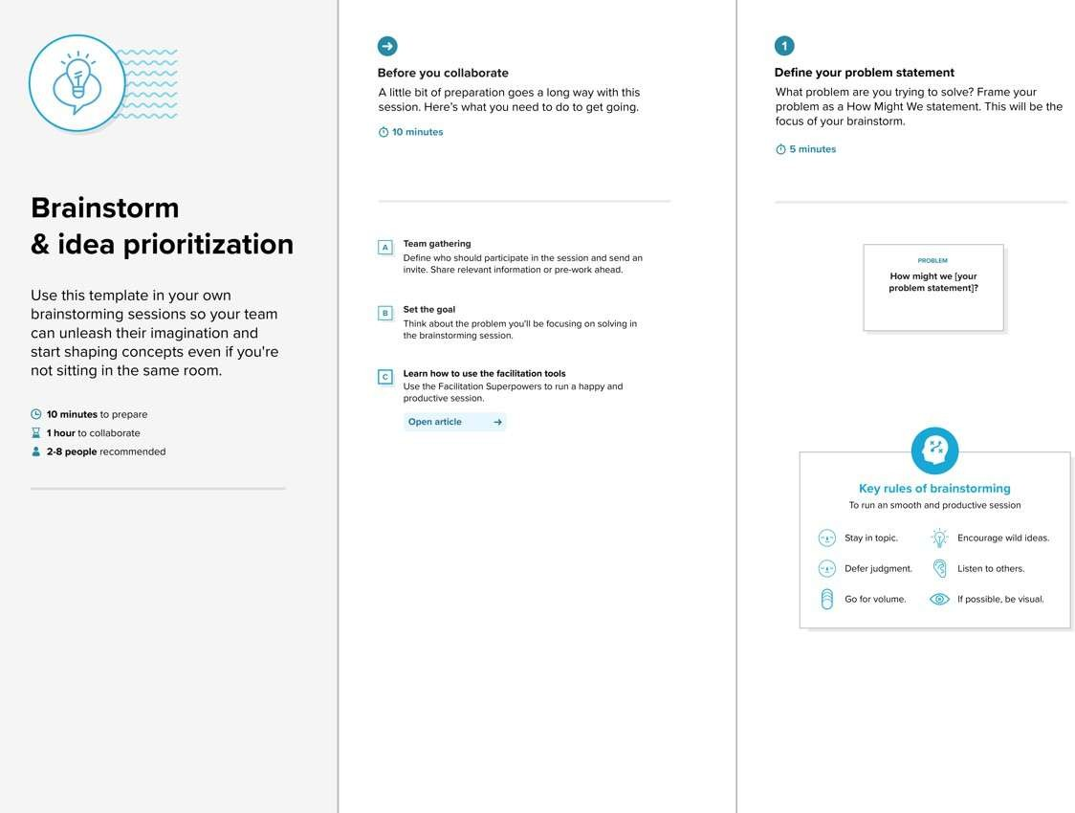

Step-2: Brainstorm, Idea Listing and Grouping

Once the problem statement is defined, the team moves into ideation to explore potential solutions for Explore with AI.

Key activities:

- Brainstorm a wide range of ideas for the app, including features such as:
  - AI-generated daily itineraries with attractions, dining, and tips
  - User input customization (interests, travel duration, activity types)
  - Exportable itineraries (PDF, text)
  - Integration with travel blogs or local guides
- Encourage all ideas, no matter how big or small.
- Documented and group ideas in a shared space to visualize feature clusters and solution approaches.
Outcome: A comprehensive list of potential features and functionalities for Explore with AI, categorized into themes like user customization, AI automation, and content generation.

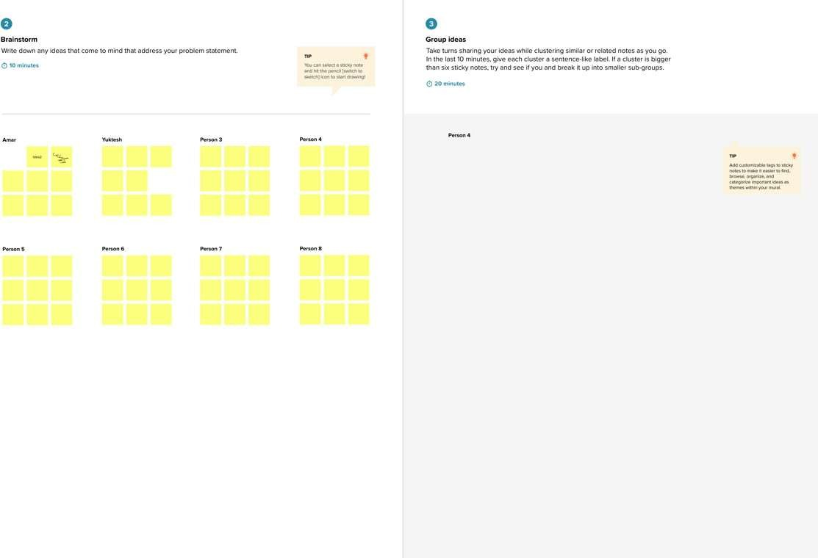

Step-3: Idea Prioritization

After gathering and grouping ideas, the team prioritizes features and solutions to focus on the highest value and most feasible elements for Explore with AI.

Key activities:

- Evaluated ideas based on user impact, feasibility, and development effort.
- Used prioritization techniques such as:
  - MoSCoW Method (Must Have, Should Have, Could Have, Won’t Have)

Impact vs. Effort Matrix
  - Dot Voting or team consensus
- Decided which features to implement first, such as:
  - Must-Have: Personalized daily itinerary generation
  - Should-Have: Dining and local attraction recommendations
  - Could-Have: Exportable itinerary formats and travel blog integration
Outcome: A focused development roadmap for Explore with AI that maximizes user value while staying realistic within the project timeline. This ensures the team prioritizes features that solve core user problems without overcomplicating the app.
